4-[UDEMY] SEO Training 2021 Beginner To Advanced SEO #1

2. SEO Basics And Important Terminology

2.1. What Is Search Engine Optimization

SEO (search engine optimization is the practice of increasing the quantity and quality of traffic to your website through organic search results

* The process of promoting a website on the major search engines to incrase traffic and sales.
* Keyword = the words and phrases that we enter into search engines, also called ‘seach queries’
* A web query or web search query is a query that a user enters into a web search engine to satisfy their information needs. Web search queries are distinctive in that they are often plain text and boolean search directives are rarely used. Wikipedia
* SEM – search engine marketing. The process of gaining website traffic by purchasing ads on search engines
* Organic search results are the web page listings that most closely match the user’s search query based on relevance. Also called ‘natural search’ results, ranking high in the organic results is what SEO is all about.

NAVIGATIONAL search queries

INFORMATIONAL search queries

TRANSACTIONAL search queries

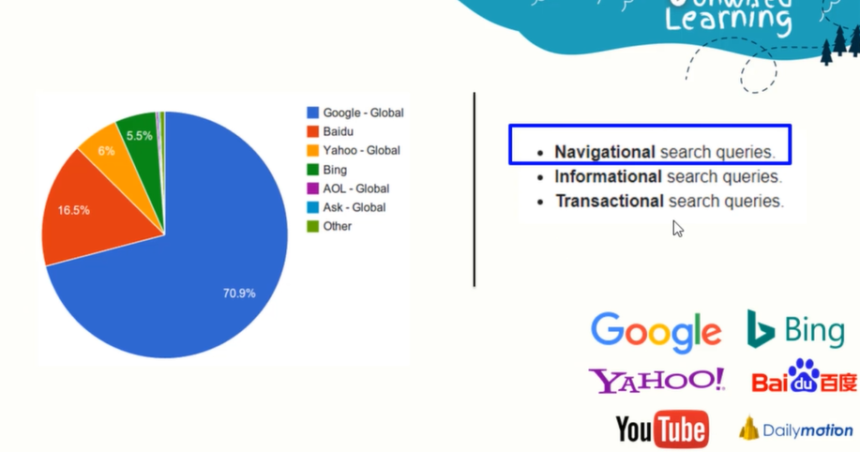

2.2. How search engine works

INDEX / CRAWL / CRAWLER / GOOGLEBOT / SEO

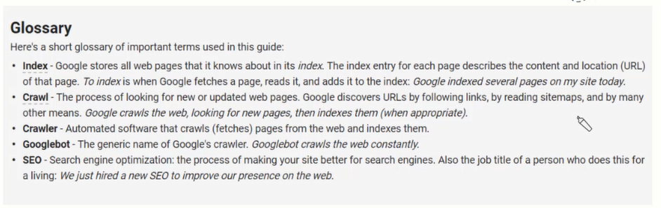

An index is another name for the database used by search engine. Indexes contain the information of the websites that search engine was able to find.

What google actually store is: the tags (header tags), titile, keyword and the URL. (META DATA AND KEYWORDS)

GOOGLEBOT = GOOGLE CRAWLER = SPIDER

SERP = search engine result page

crawler

1.a thing that crawls or moves at a slow pace, especially an insect.

"the light bulb was a magnet for moths and many-legged crawlers"

2.COMPUTING

a program that systematically browses the World Wide Web in order to create an index of data.

Fetching (data) = aducerea / colectarea de date

big chunk = bucată mare

2.2.1 How search works

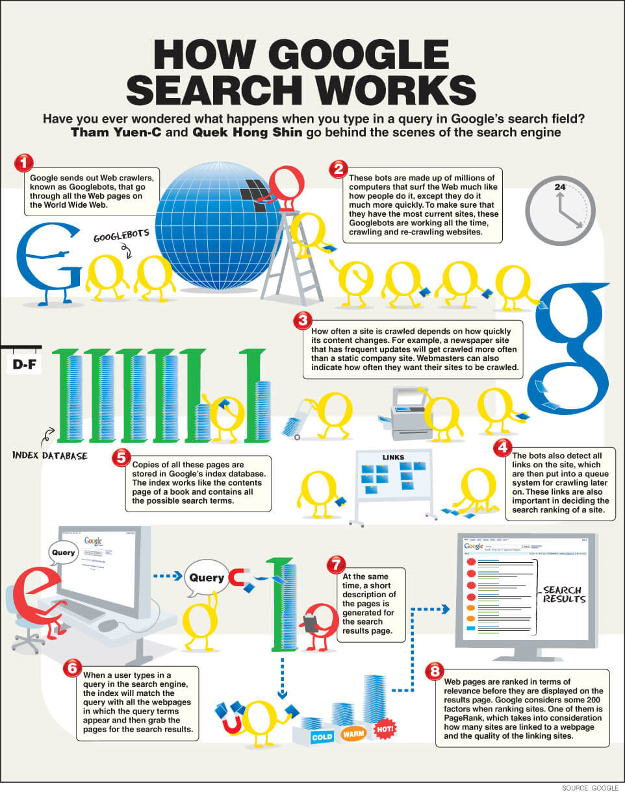

2.3. SEO Vocabulary I

Seo jargon / key seo related terminology and concepts you should know.

ANCHOR TEXT

BACKLINKS – an incoming hyperlink from one web page to another website. When a webpage links to any other page, it’s called a backlink.

/contextual links , image links, sidebar widget, sitewide Link (\*links that appears on most or all of a website.

2.3. SEO Vocabulary II

Types of backlink sources

Blog, Company site, directory, guest post

Comment, Web2.0 site, Social media, Wiki, social bookmark, PBN, Press Release… any many more.

Guest posting – is the practice of contributing a post to another person’s blog in other to build relationships, exposure, authority and links.

Web2.0 website along user to interact and collaborate with each other, share the information online. Examples: wix, Tumber, WordPress erc. It is helpful in seo

Media – facebook, twitter, google+, Instagram, Pinterest, Reddit and more.

*Priority of souce depend on wevsite;s domain authruty, Page authority, page rank, it’s ranking etc.*

Keywords

Keywords Research, monthly search volumes, LSI (Latent symatinc index), primary & secondary keywords, keyword surfing, keyword difficulty

Keywords surfing = refers to the practice of loasding a webpage eith keyword or numbers in an attempt to manipulate a site’s ranking in google search results.

EX: 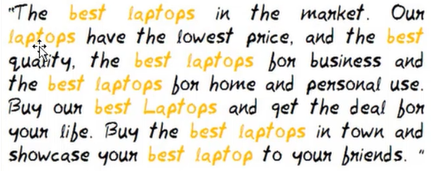

5. SEO Vocabulary – III

Organic SEO vs Local SEO

Different Algorithms for each Maps Ranking, 3 Pack, Google My Business(GMP). Citations via NAP (Name, Adress, Phone)

A URL slug is the exact address of a specific page or post on your site.

6. SEO Vocabulary – IV

Keyword types

* + Exact match
  + Phrase match
  + Broad match

